Point your browser to the FLVS curriculum website. | https://login.flvs.net/
Use your Parent Account credentials to log in. | 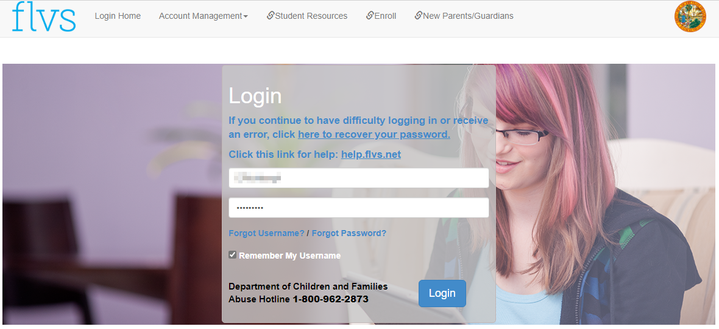
Click on VSA – Virtual School Administrator | 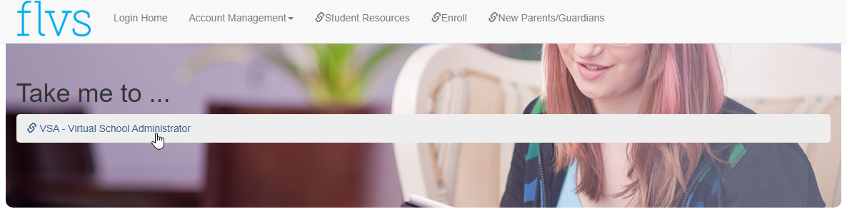
Answer any questions that may come up. | 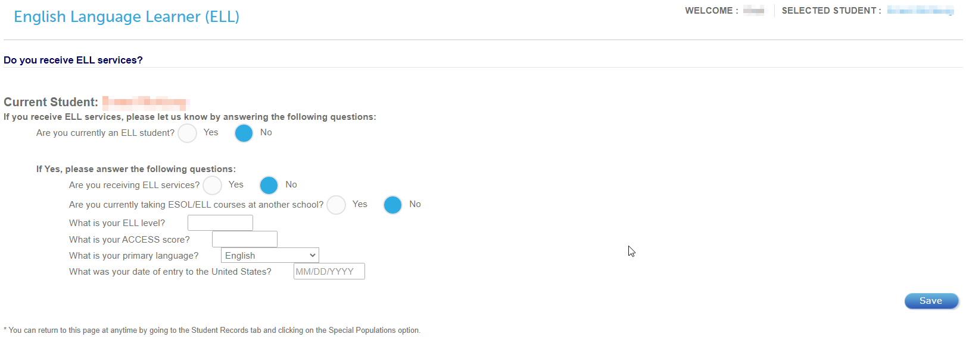
Once logged in you will see the Student Dashboard. | 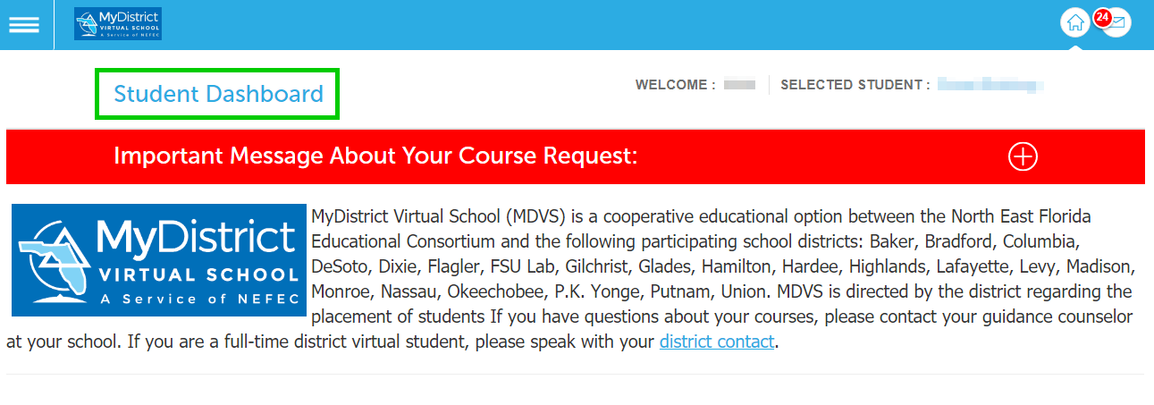
Scroll down until you see the Student Context Selection dropdown menu. Make sure that you have chosen the student you plan to approve courses for. | 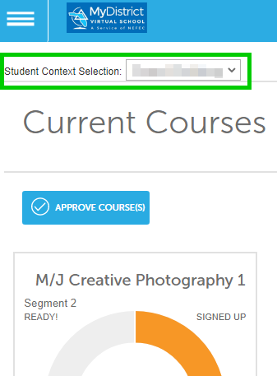
 | 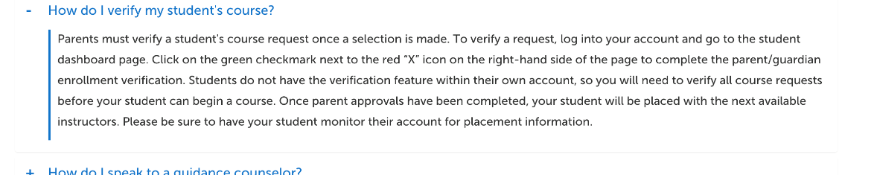
Click on Approve Course(s) | 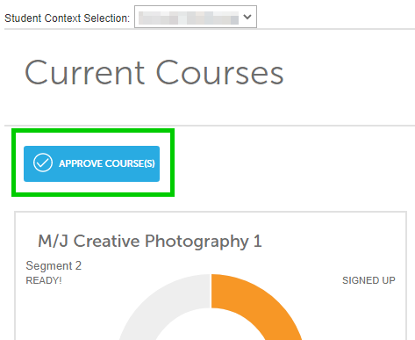
Click on specific courses or choose Select All Enrollments. | 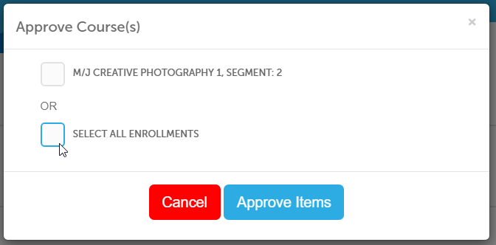
Click on Approve Items. | 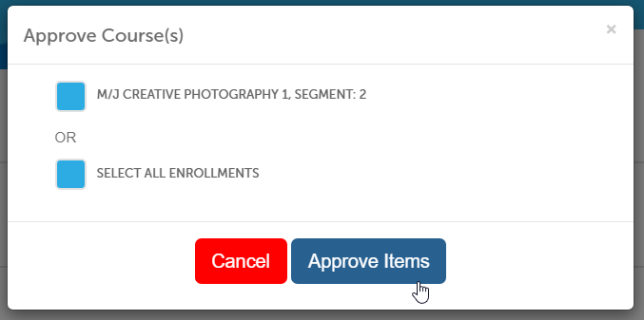
The next step is Guidance Enrollment Verification. | 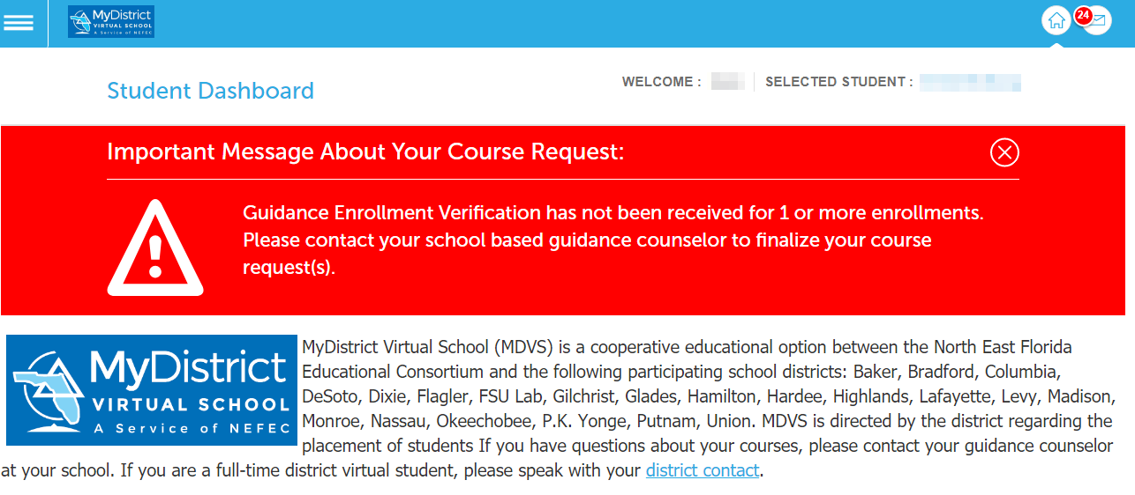
Please contact your Home Education liaison in the district where you reside to request approval for these courses. If you have not submitted the Intent to Home School paperwork, they will guide you on completing that before approving courses. | Home Education contacts by school district  Additional Resources can be found:  Florida Department of Education

